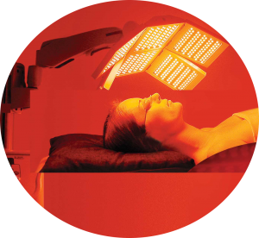Treatment Protocols

**Anti Aging (LW1)**

LIGHTWAVE proprietary LED light Therapy session (Red and/or IR Light) designed to re-hydrate the face, and increase collagen and elastin formation resulting in a reduction of fine lines and wrinkles. It aids in decreasing flaccidity, lifting sagging tissues, and restoring skin tone and texture resulting in an overall improvement erasing years from the face. Ten treatments are recommended. Maintenance once a month or as needed can prolong the youthful appearance.

**Pigmentation (LW2)**

LIGHTWAVE proprietary LED light Therapy session (Red and/or IR Light) intended to improve discoloration caused by sun damage, chemical build-up, and chemical reactions from chemical peels, and excessive use of skin damaging products. This process normalizes the melanin within the skin. The amount of treatments needed vary depending on the amount of damage to the skin, the thickness of the skin, and the age of the client. Severe conditions such as Melasma may be best treated with a combination therapy of topical ointments such as hydroquinone, and/or IPL, and/or laser followed by LIGHTWAVE Therapy.

**Scars (LW3)**

LIGHTWAVE proprietary LED light Therapy session (Red and/or IR Light) uses powerful Infrared and red light to stimulate the reduction of fibrotic tissue and the replacement of normal tissue. Clients usually notice softening of scar tissue. They also notice flattening and widening of the scar. This is a normal sequence in scar reduction. With several more sessions the flat, wide scar will become thinner and remain flat. Some scars may appear to be resistant to this program (hypertrophic and/or keloid). If this is the case, a customized LIGHTWAVE treatment protocol and/or additional treatment options may need to be considered.

**Preventative Care (LW4)**

LIGHTWAVE proprietary LED light Therapy session (Red and/or IR Light) is designed to increase blood circulation and bring more nutrients to the skin’s surface which helps to keep the skin from breaking down. It also helps to normalize dry or oily skin, achieving an overall improvement in skin tone and texture.

**Flaccid Skin (LW5)**

LIGHTWAVE proprietary LED light Therapy session (Red and/or IR Light) that focuses on skin retraction by increasing circulation and bringing nutrition to damaged tissue. This program is particularly effective over the abdomen, neck, and upper chest. Treatments should be applied twice per week and may require between 10 – 15 treatments.

**Discomfort/Pain (LW6)**

LIGHTWAVE proprietary LED light Therapy session (Red and/or IR Light) specifically designed to address inflammation associated with trauma and/or an allergic reaction that causes discomfort with a focus on clients who experience persistent problems such as joint and muscle discomfort. It is also used within 72 hours of any traumatic event including post-surgical interventions to reduce scarring and encourage normal tissue formation.

**Red/Infrared**

This program is designed to allow the user to provide a protocol specific for a treatment condition that has not been  
addressed by one of the other pre-set protocols and has been shown to benefit from intense red and infrared light. It  
utilizes 15 minutes of continuous narrowband red light followed by 15 minutes of continuous narrowband IR light.

**Infrared**

Infrared (IR) light (wavelength 800nm – 900nm) energy penetrates tissue at a greater depth than the blue and red light. Approximately 50% penetrates to 8cm and decreases to less than 1% at 20cm (NASA study). Infrared energy is known to heat tissue and its effects are well documented for therapeutic pain management. For cosmetic applications, IR stimulates the NaK+ pump which increases cell membrane permeability; facilitating equilibrium of cellular pH, while increasing nutritional absorption and elimination of waste byproducts.

**Red Only**

Red light (wavelength 625nm-660nm) penetrates human tissue superficially, with approximately 80% of the energy being absorbed in the first 2cm. Red light energy has a significant effect on mitochondrial stimulation, which increases the production of ATP and in turn boosts fibroblast activity. This leads to an increase in cellular turnover, superficial circulation, and an anti-inflammatory emission.

**Blue/Red Mild to Moderate Acne (LW10)**

LIGHTWAVE proprietary LED light Therapy session (Red and Blue Light) designed to repair damaged skin and significantly reduce the P. acnes, the bacteria responsible for causing inflammatory acne vulgaris. 15 minutes of Blue light first enters the sebaceous glands and singlet oxygen is created. Singlet oxygen then in turn kills the bacteria. Next, the client is exposed to 15 minutes of red light. This acne treatment aids in the healing process of the skin and prevents infection and scarring from occurring.

**Blue Only**

Blue light (wavelength 405nm-450nm) provides a very superficial penetration even with a high- intensity narrowband light source. It is primarily absorbed by the epidermis of the skin. Once it is absorbed, blue light targets P. acnes by stimulating porphyrins which then produce intracellular singlet oxygen and thus inducing bacterial death.

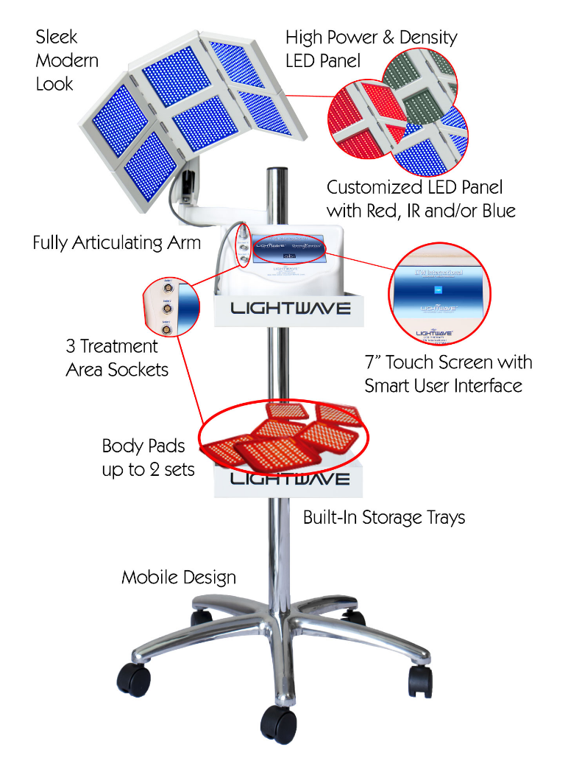ELITE LWTS 2280

Clearskin relationship price: $6400 plus shipping

THE MOST ADVANCED

LED Light Therapy On The Market

LIGHTWAVE’s DELUXE ELITE™ series is the most advanced professional grade LED Light Therapy (LEDt) system and offers the most sophisticated and versatile features available in the market. Our technology has received multiple FDA clearances, back by significant scientific data, years of field service and a commitment to excellence.

EXTREME CUSTOMIZABILITY

**Up to 4080 LEDs**

The DELUXE ELITE™ series can be customized to fit your needs and is capable of utilizing up to 4080 powerful non-invasive LEDs. The DELUXE ELITE™ can be configured to include clinically proven monochromatic Red Light Therapy, Infrared Light Therapy and Blue Light Therapy wavelengths all in one system without changing heads.

PAD SETS

LIGHTWAVE’s Auxiliary Pad Sets are light and flexible, allowing for treatment to occur anywhere on the body. Primarily used for soft tissue injuries and acute or chronic pain; the pad-sets can also be utilized for other treatments. Each pad set contains 600 LED’s consisting of Red and Infrared (IR). Multiple sets can be operated simultaneously. Auxiliary pad-sets are not available with Blue light

React Pro LT

Clearskin relationship price: $2999 plus shipping

POWER + AFFORDABILITY

**Multi-Color LED Light Therapy System**

The ReAct series is a sophisticated and versatile Tri-Color (Red/IR/BL) LED light therapy system. This affordable system offers many of the features of our flagship LIGHTWAVE ELITE series, but without the price tag.

EXTREME VERSATILITY

**2 Technologies in 1 System = More Treatments and Value**

Why settle for less! The only professional quality tool available with **both LIGHTWAVE LED and Topical Light Infusion (TLi)** for the face and body in one system.  Get equipment and features you need without breaking the bank. The ReAct series offers you flexible design, hands-free use, high output and reliability all in a small footprint. ReAct series offers two versions with multiple configurations to meet you needs.

